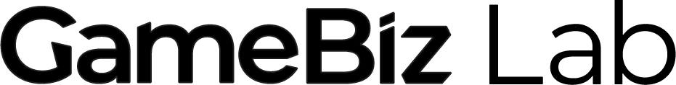


Applicant Eligibility and Application Form

GameBiz Lab is bringing education and consulting around the business side of video games to Manitoba’s video game community.
For new and aspiring video game studio owners: Apply to be part of the 2024-25 GameBiz Lab cohort. Benefits include:
- Priority access to consultations with industry experts
- The ability to book NMM’s space, subject to availability
- Monthly coworking opportunities*
- Additional benefits as confirmed
Eligibility:
- Be a resident of Manitoba
- Leading, helping lead, or planning to start a video game studio in Manitoba
- Be willing and available to participate in monthly events and gatherings. Virtual options can be arranged for approved participants located outside of Winnipeg, Manitoba.

Applications will be assessed based on potential for success (such as past experience in the video game industry or related fields, current maturity of the studio, etc.), as well as NMM has committed to having at least 50% of participants be from equity-seeking communities.

Please submit this form to corinne@newmediamanitoba.com to apply for the GameBiz Lab Cohort Program running from September 2024 - April 2025

If you do not receive an acknowledgment of receipt within 2 business days, please resubmit. All applications must be submitted by Friday, July 19th, 2024. Approved cohort participants will be notified by Friday, August 9th.

*New Media Manitoba will organize opportunities to meet in our training space during times designated for the cohort to be able to work alongside each other, mingle, and ask questions.

General Questions
Full Name
Are you starting your own Manitoban video game studio or part of leading a Manitoban video game studio created in the last five years? Yes/No
Studio Name
(Your studio does not have to be incorporated.)
Current Project Name
Community of residence (This program is only available for residents of Manitoba.)

Project Questions
Please share more about your studio and current project. GameBiz Lab is meant to support new and aspiring studio owners to increase their success through business advice and support. As such, we are not requiring a comprehensive project plan and market analysis, but we do expect applicants to have complete responses to the following questions:

- Please briefly describe your experience with video game development and work background. (1-3 paragraphs)

- Briefly describe your studio, when it was established, and your studio’s vision (1-3 paragraphs)

- Describe your current team (including any contractors) (1-3 paragraphs)

- Briefly describe your current game project (1-3 paragraphs)

- Please share your current progress and the preliminary project plan & roadmap (no more than 5 paragraphs)

- How do you see New Media Manitoba’s support in helping you succeed with your project?

- Do you anticipate any barriers that would affect your ability to attend monthly evening sessions with experts, monthly one-on-one consultations during work hours, and monthly meetups with other cohort participants?

- Please attach any further information on your marketing plan, project budget, competitive analysis, and original IP (versus work for hire).
  - Project budget (a rough outline of projected spend during the project in categories like labour, admin, hardware, etc.)
  - Marketing plan (competitor analysis, target audiences, etc.) (no more than 3 paragraphs)

Demographics and Self-Declaration Questions

I use the following pronoun(s) (You may choose more than one)
- She/Her
- He/Him
- They/Them
- Any pronouns
- Other, please specify __________________
- I prefer not to answer

2. I am a Canadian citizen or permanent resident
- Yes
- No

3. I am a resident of Manitoba
- Yes
- No

4. NMM is committed to serving individuals from underrepresented groups with this program.
Please select any of the following Equity-seeking communities that you belong to:
- Indigenous peoples to Canada
- Racialized Communities
- Women or gender-diverse individuals
- 2SLGBTQ+
- Disabled persons or persons with disabilities
- Official Language Minority Communities (Francophone in Manitoba)
- None of the above
- I prefer not to say

Please submit your completed application to corinne@newmediamanitoba.com by Friday, July 19th, 2024.

